NAME:PRIYANKA.E ROLLNO:231901038

|  |  |  |
| --- | --- | --- |
| **Ex.No.: 1** | | **CREATION OF BASE TABLE AND**  **DML OPERATIONS** |
| **Date:** | 26.7.24 |

AIM:

To create the table and perform the DML operations.

## ALGORITHM:

**STEP-1:** Start.

**STEP-2:** Create a base Table

Syntax:

CREATE TABLE <table name> (column1 type, column2 type, …);

**STEP-3:** Describe the Table structure Syntax:

DESC <table name>

**STEP-4:** Add a new row to a Table using INSERT statement.

Syntax:

* + INSERT INTO <table name> VALUES (value1, value2..);
  + INSERT INTO <table name> (column1, column2..) VALUES (value1, value2..);
  + INSERT INTO <table name>VALUES (&column1,‘&column‘);

**STEP-5:** Modify the existing rows in the base Table with UPDATE statement.

Syntax:

UPDATE <table name> SET column1=value, column2 = ‘value‘ WHERE (condition);

**STEP-6:** Remove the existing rows from the Table using DELETE statement.

Syntax:

DELETE FROM <table name> WHERE <condition>;

**STEP-7:** Perform a Query using SELECT statement.

Syntax:

SELECT [DISTINCT] {*,<column1,,..>} FROM <table name> WHERE <condition>;

**STEP-8:** The truncate command deletes all rows from the table. Only the structure of the table remains.

Syntax:

TRUNCATE TABLE <table name>;

**STEP-9:** Alter the existing table using ALTER statement.

Syntax:

Add Column:

ALTER TABLE <table name> ADD (column data type [DEFAULTexpr][,column data type]);

Modify Column:

ALTER TABLE <table name> MODIFY (column data type [DEFAULT expr], [,column data type]);

Drop Column:

ALTER TABLE <table name> DROP COLUMN <column name>;

**STEP-10:** To drop the entire table using DROP statement.

Syntax:

DROP TABLE <table name>;

**STEP-11:** Exit.

1.Create MY EMPLOYEE table with the following structure

|  |  |  |
| --- | --- | --- |
| NAME | NULL? | TYPE |
| ID | Not null | Number(4) |
| Last_name |  | Varchar(25) |
| First_name |  | Varchar(25) |
| Userid |  | Varchar(25) |
| Salary |  | Number(9,2) |

CREATE TABLE MY_EMPLOYEE(

ID number(4) Not null,

Last_name Varchar (25),

First_Name Varchar (25),

Userid Varchar (25),

Salary Number (9,2)

);

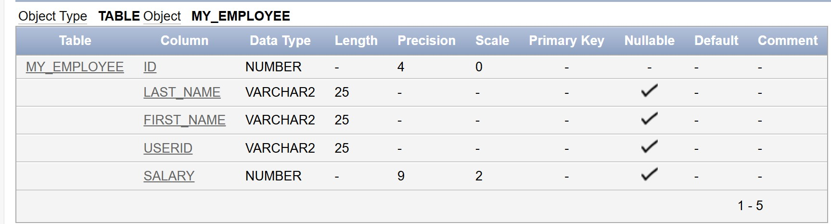

2.Add the first and second rows data to MY_EMPLOYEE table from the following sample data.

|  |  |  |  |  |
| --- | --- | --- | --- | --- |
| **ID** | **Last_name** | **First_name** | **Userid** | **salary** |
| 1 | Patel | Ralph | rpatel | 895 |
| 2 | Dancs | Betty | bdancs | 860 |
| 3 | Biri | Ben | bbiri | 1100 |
| 4 | Newman | Chad | Cnewman | 750 |
| 5 | Ropebur | Audrey | aropebur | 1550 |

INSERT into MY_EMPLOYEE values(1,'Patel','Ralph','rpatel',895);

INSERT into MY_EMPLOYEE values(2,'Dancs','Betty','bdancs',860);

3..Display the table with values.

SELECT *from MY_EMPLOYEE;

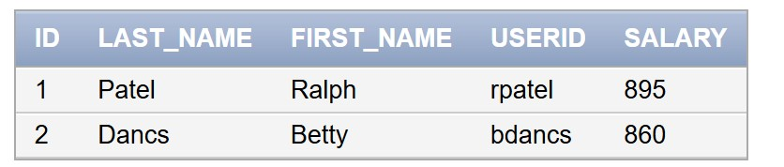

4. Populate the next two rows of data from the sample data. Concatenate the first letter of the first_name with the first seven characters of the last_name to produce Userid.

INSERT into MY_EMPLOYEE values (3,'Biri','Ben','bbri',1100);

INSERT into MY_EMPLOYEE values (4,'Newman','chad','Cnewman',750);

INSERT into MY_EMPLOYEE values (5,'Ropebur','Audrey','aropebur',1550);

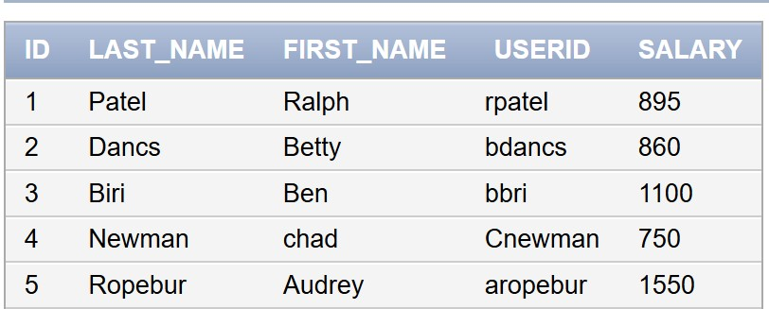

5.Delete Betty dancs from MY _EMPLOYEE table.

DELETE from MY_EMPLOYEE where First_name='Betty';

6.Empty the fourth row of the emp table.

DELETE from MY_EMPLOYEE where ID=5;

7.Make the data additions permanent.

COMMIT;

8.Change the last name of employee 3 to Drexler.

UPDATE MY_EMPLOYEE set Last_name='Drexler' where ID=3;

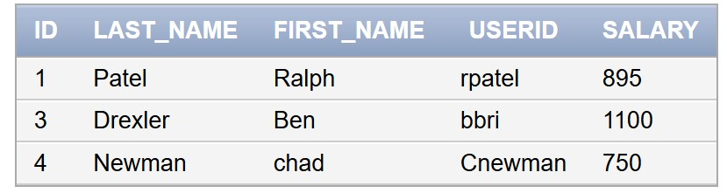

9.Change the salary to 1000 for all the employees with a salary less than 900.

UPDATE MY_EMPLOYEE set Salary=1000 where Salary<900;

